C5 Corvette Intermittent Directionals and Hazard Switch/Flasher Replacement

The C5 has a fairly common problem in that the directional lights intermittently do not work. When this happens, turn your hazard lights on then off. If your directionals then resume working, the hazard switch is the culprit. If you follow the GM shop manual, you’ll tear the car apart and it will take you a week and a day……, or cost you a fortune to replace it. Here’s a quick and dirty way to get at the switch (P/N 10359036, List $32.83) which is up in the dash to the left of the center AC vent.

1- Empty the console and locate the two plugs at the rear. Remove the plugs by snapping out with a small screwdriver and remove the nuts with a 10 MM socket.

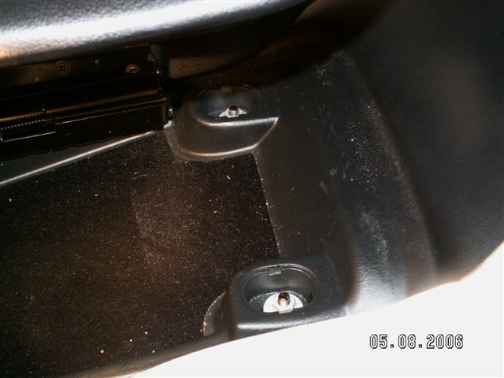

2- Remove the panel with the traction control button and airbag off indicator by prying up with a screwdriver. Disconnect the wiring.

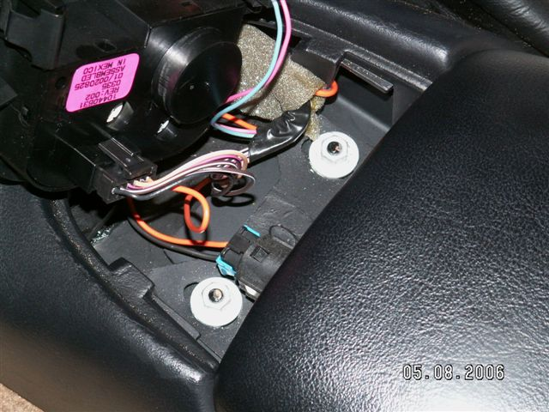

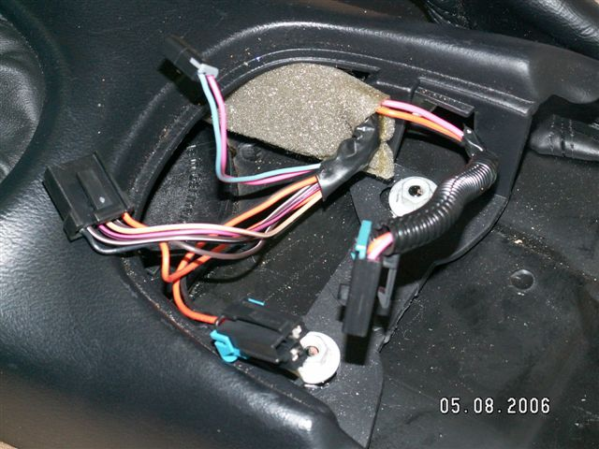

3- Remove the forward two nuts holding the console with a 10 MM socket.

4- Disconnect the wiring to the fuel filler door release, then remove the rear portion of the console by pulling back and upward.

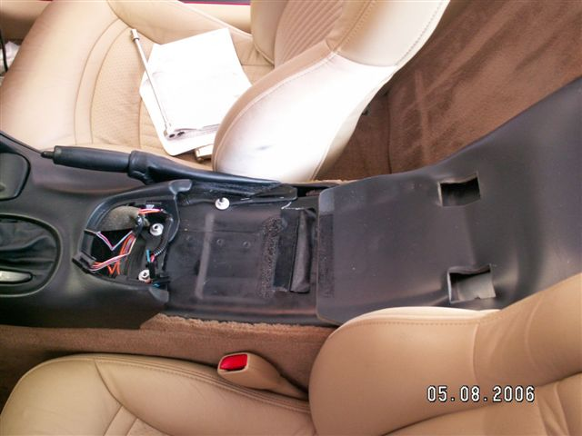

5- Gently pry off the cover to the left of the ignition switch with a screwdriver and remove the torx screw with a T15 wrench.

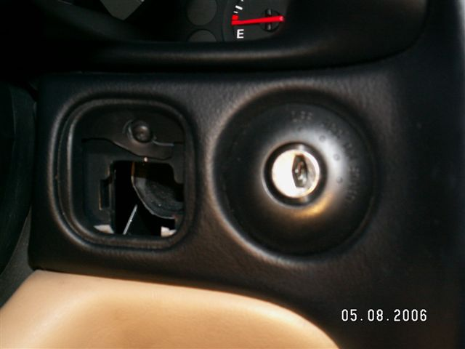

6- Open the ash tray cover and remove the ashtray. Remove the torx screw to the left of the lighter and the one behind the ashtray.

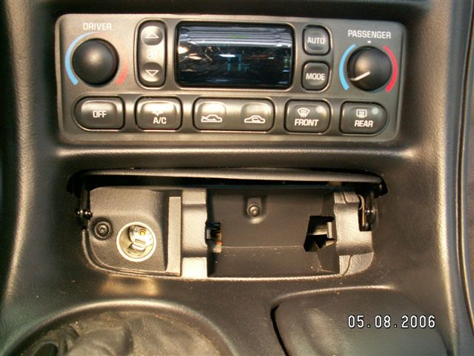

7- You are now ready to remove the forward part of the console including the vertical stack cover that surrounds the radio, AC controls and ignition key. You might want to put the shifter in Low (A4) or 4th (6SP) and pull the emergency brake up some to get the console out. Disconnect lighter wiring. Don’t force anything, it will come.

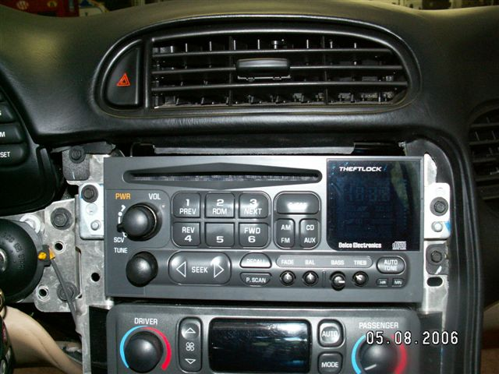

8- Remove the two 7 MM screws that retain the radio. Pull the radio out and around toward the steering wheel so you can get at the wiring harnesses to disconnect them. Pinch the retainers and pull them out, they might be a little stubborn. Pull out the antenna connector. You are now ready to change the switch.

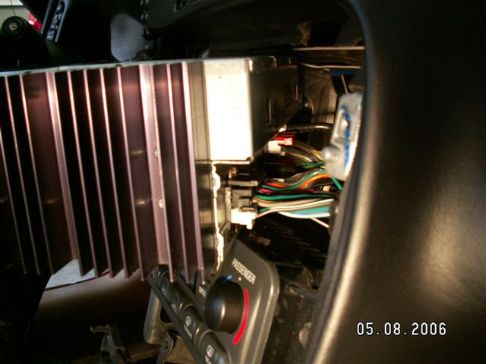

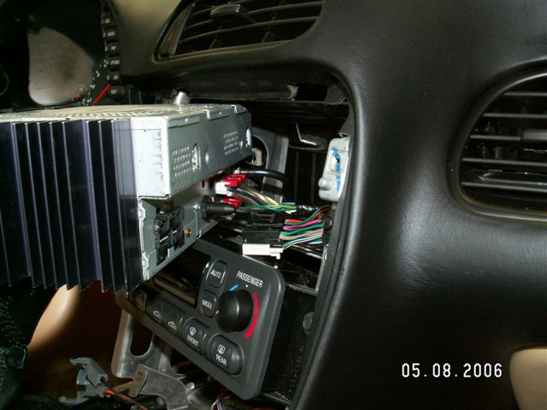

9- Carefully pry off the Hazard switch button with a small screwdriver. Look into the hole where the radio was and you will see the bottom of the switch. Look at the new switch, so you can see how it attaches. Push up on the bottom snap to release it. The top one is inaccessible soooo…… Here’s the trickiest part. Once you have released the bottom snap, the switch can be popped back with a mild tap using a large screwdriver and the palm of your hand. Place the screwdriver vertically on the green part of the switch to the right and give it a rap. It should pop free. Now you can reach up through the opening and pull it down into the radio cavity with the wiring still attached. Watch out, those edges are sharp! It might take a little fishing with a long thin screwdriver and/or long thin needle nose pliers to guide it through, but be patient, it will come. Once out in the open, unplug the connector, plug it into the new switch and reinstall. Make sure new switch snaps securely into place.

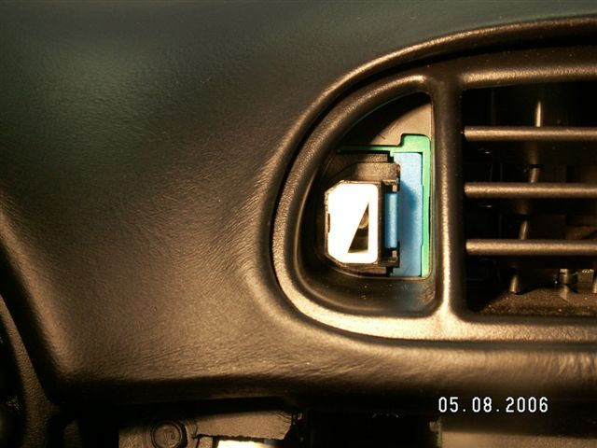

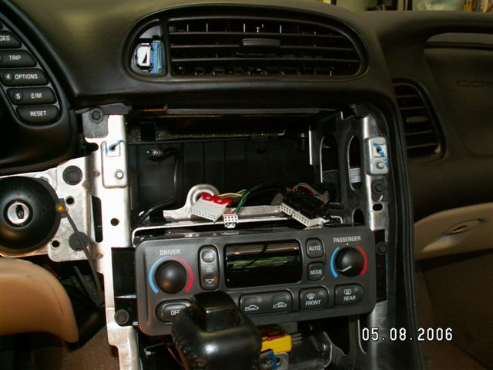

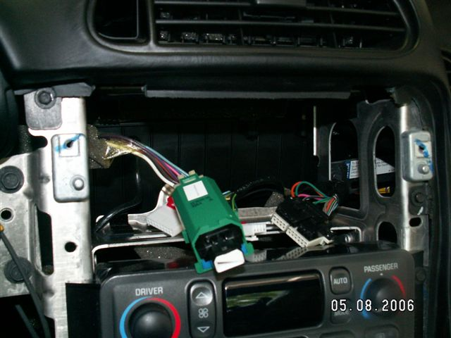

10- Now, after checking that the directionals and hazards work, just reverse the process and put everything back together.

11- Pat yourself on the back…… you just saved some big bucks!!

May 9, 2006

Any questions, email me at neil@neilkline.com and I’ll try to help.

