C5 Climate Control dim/dark display fix

First and foremost, this is not my fix! I spent a while searching multiple forums on info on how to do this, and found it all in several places. All I'm doing is collecting the info I found to put it in one step by step place with minor footnotes of my own. I will list names and URL's to each area I found the info from, and if anyone would like their info removed I will gladly do so!
Just trying to save the next poor guy some time for looking all over and following all the various links from everywhere
Hope this helps!
For the first steps, find pictures and more detailed instructions where I did, at http://www.vetteessentials.com/instr...zel_howto.html
Their list of tools is for a bigger job, you wont need all of the ones listed, you'll need others for actually fixing the control unit, and you only need to go to step 3g, no further for this section!
***If you have a convertible with the body colored "waterfall" you will have to remove it first. If not, skip this step. 4 screws total, size 15 torx screws, two on the top, one on each side towards the bottom. Just gently pull up to remove it.
Remove the console - Gently remove the Active Handling trim plate and wiring connections beneath it and to the console. Remove the 4 10mm nuts. Pick up only the back of the console to get it over the rear bolts, then slide it towards the back to get it out from the front bolts. The front is slotted to slide all the way out.
Remove the instrument trim panel - Gently pry out the trim panel to the left of the ignition switch, and remove the ashtray. Remove the 3 #15 torx screws. GENTLY pull the panel only a little ways! Back towards the top, and up at the bottom/back where 2 of the 10mm nuts were removed from the front of the console area (behind the shifter). Remove the cigarette lighter power. ***If it's a 6spd, remove the boot carefully, I pulled mine up, but this site says you can push it down also*** Once you've verified everything is free, carefully pull it out and set it safely aside.
Again, I highly recommend going to the following site http://www.vetteessentials.com/instr...zel_howto.html for pictures and a more detailed step by step instructions for the above steps.
The following steps are not found at the above URL.
Now you have a clear shot to your Climate Control unit! There are only 2 screws holding it in place. I'm sorry I didn’t get the size of them, but they're easily accessible to test a few sockets to find the perfect match Remove the screws, pull the unit out a little way, and remove the connector in the back. Pay attention to the connector, there's an area you have to press to release the clip to be able to pull it out.
Now that you have the unit out, take it to a safe place, preferably the clean worktable you will be finishing the work on it
Carefully remove the 4 screws on the corners holding it together. They are small, and have very coarse threads, so use a hand screwdriver style tool preferably, NOT a drill, if you only have a ratchet set, just be very careful not to over tighten it when you're done!
The following was ninja'ed from RPOZ4Z at Corvette Forum http://forums.corvetteforum.com/show...1316227&page=2 on page 2 post # 24. Thank you VERY much RPOZ4Z for putting words to sight so I knew what the hell to solder!!!
Originally Posted by RPOZ4Z
I just finished fixing mine!
It works like new!
I'll post some pics in a little bit.
basically I just touched up the soldering on the big surface mount resistors on the power supply board.
here are the pics..................................
remove the 4 screws from the back of the HVAC control, when you take it apart this is what you will see.
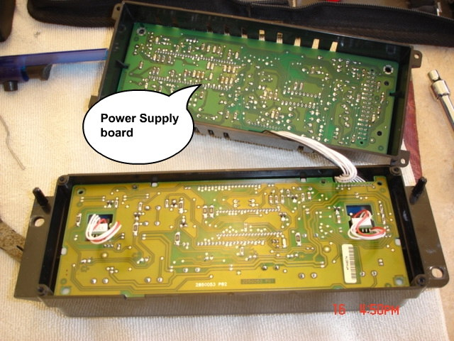
remove the 4 screws holding the power supply board to the back cover, and flip the board over.
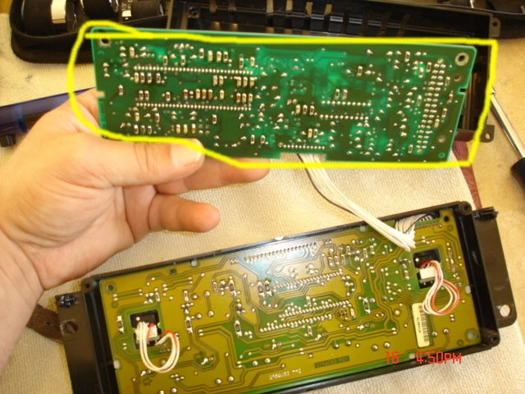
there are 8 surface mount components (outlined in yellow), these are the "culprits".
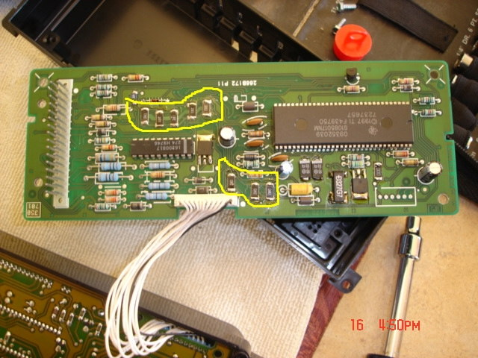
with a soldering iron, touch up the solder joints on these components, be careful, due to the bad soldering, they may move from their locations on the board, if they do, use a pair of tweezers of small needle nose pliars to reposition them and hold them in place while you solder one side. don't use a soldering gun or too much heat, chip components tend to get damaged by too much heat.
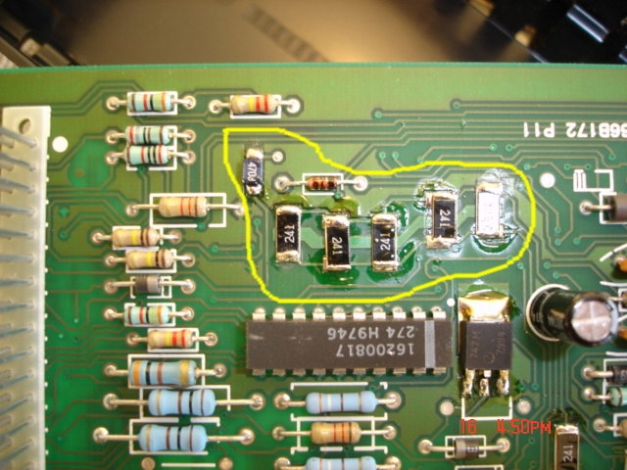
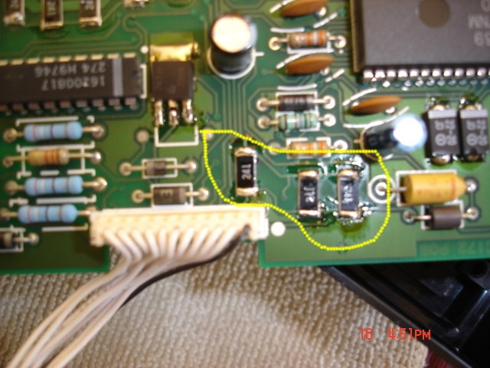
(please pardon my crappy soldering, I did this in a hurry on my kitchen table right before dinner!)
There is a 2nd variation of this board, which is the one I found in my 01 convertible. Thank you EnglandGreen for posting the other kind of board as seen below! http://forums.corvetteforum.com/show...1316227&page=3 Same thread, page 3 post #50
Quote:
Originally Posted by EnglandGreen
Of course, my HVAC is totally different from all of the others posted. What a surprise.
This image has been resized. Click this bar to view the full image. The original image is sized 1024x731.
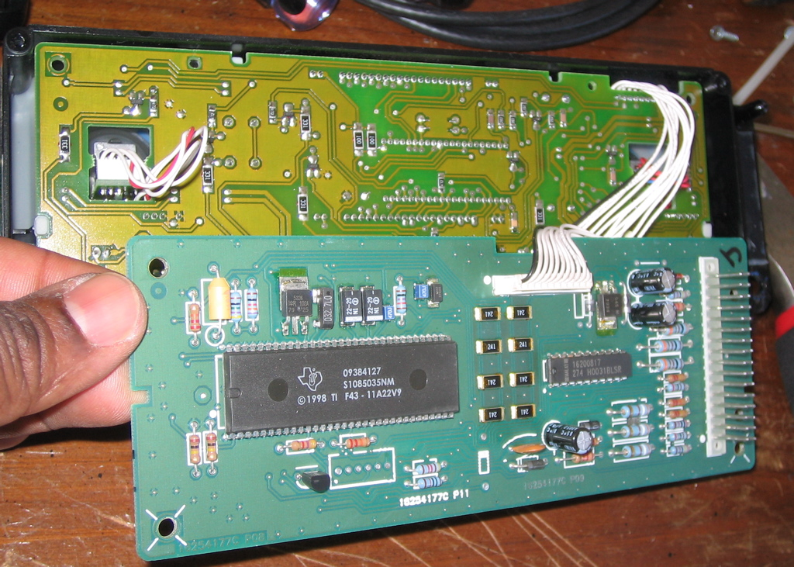
Still: I soldiered on and soldered all the surface mounted resistors nonetheless.
This image has been resized. Click this bar to view the full image. The original image is sized 1023x751.
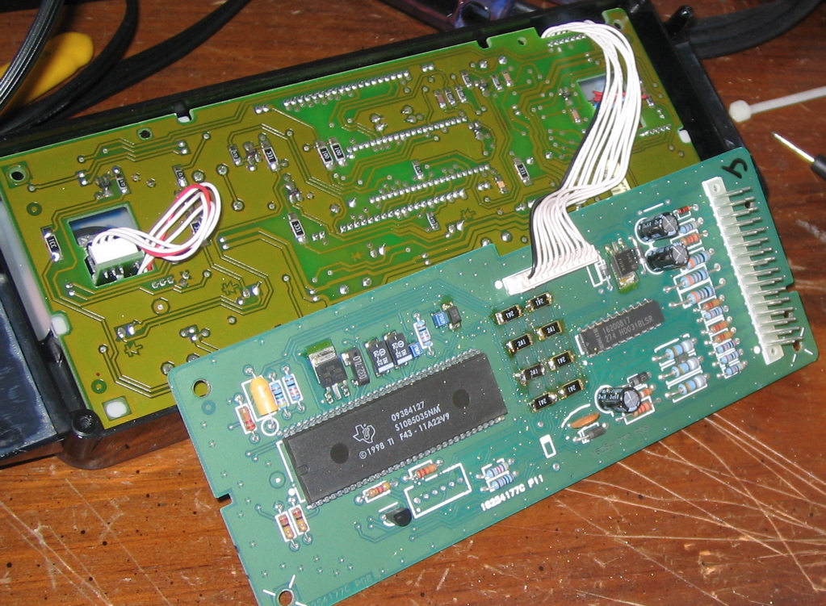
Success!! Works like new!!
This image has been resized. Click this bar to view the full image. The original image is sized 1024x768.
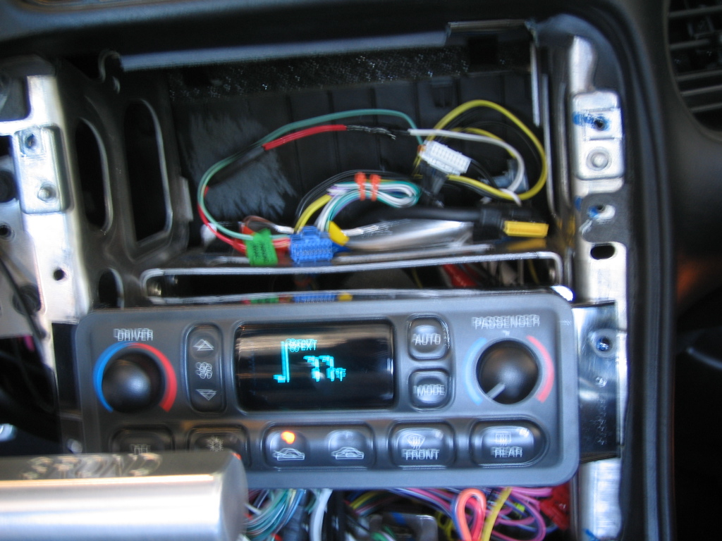

On both boards, it's very easy to unplug the power board from the front of the unit to work on it. And on either board, what you're looking for is those little black guys with "241" printed on them. I used a Cold Heat soldering gun I got from Radio shack an hour or two earlier in my then together car The tip it came with was not ideal, but it finally got the job done!
I tried to see which seemed loose and only solder those few. Don’t bother trying, either you wont be able to tell, or you'll break them off looking for the loose ones. I fixed the 2 obvious ones, and went out to the car to try it, but only got a very dim light. When I went back and soldered more they were practically ALL broken on one side
Be careful to try and hold them in place so they don’t move if you happen to solder the good end first. I had one come completely off the board, and it was very hard to get it back on. I eventually wound up putting solder on the contacts on the board first, then putting the chip back on and soldering, it was a pain. I just rested the back of a tiny jeweler’s screwdriver on them to keep them in place, it doesn’t take much.
When you finally have them all done on both sides, carefully put the unit back together. Be sure to line up the pins on the back cover, and be careful with the small coarse threaded screws. I put them in the hole, turned them backwards until I felt where the thread was and then gently screwed them in until tight. You do not want to torque them at all, it will be obvious when they're tight and you're against the circuit board. Same with the screws that hold the casing together.
Now before you put everything back together in your car, make sure you turn the ignition on to make sure it lights up! You don’t need to start the car, just put it in the on position. Assuming everything works, CONGRATULATIONS! Follow the steps in reverse order to put everything back together, reconnect all the electrical items, and make sure not to strip or over tighten anything. One thing I did notice is the screw behind the ashtray seems loose when you're putting it back together at first. It's just the nature of the clip. Once the dash is in position and you snug it up it will get tight.
Now that I know what I'm doing, it really is a quick job! If you read up and study the pictures first, it should go pretty smoothly long as you or someone you know can solder ok
Cordless Coldheat Soldering gun - $19.99
4 pack AA batteries - $3.99
.022 dia High Tech Rosin Core Solder - $3.99
Saving $500 and a day spent at the dealership with no car - priceless!
-ALSO!!! If you DONT want to risk soldering it yourself, try a local reputable electronics expert. Long as you can show him what's broke he can probably fix it. Or if you have time to wait for mail have an expert do it for you!!! I don’t know this person at all, I just found the following in my search!
From member rws.1 http://forums.corvetteforum.com/show...t=David+Ruberg post #2

